Hi guys,
I’ve been lurking on FF forum for about a year, just wanted to share my thought hoping for good feedbacks from all you guys. So here’s my thought,
I’m busy doing my job since I’m an employee, so I wanted to have a minimum control of my chart, I just want a daily control, secondly there is no EA that works forever since the market is changing overtime so I have to “drive” the EA manually ( set the EA “Long only” or “Short only”). So far it ganerates at least 500pips per month. It's very simple and easy, I’ll show you how.
1. Put the EA on 5 Min chart
2. Put the template and indicator on your daily chart
How to start and “drive” the EA
1. See the trend on daily chart just like the pic below,
2. When you see the trend down on daily chart, “Drive” the EA “Short only” on your 5 min chart, and vice versa
3. When you see the trend is changing on daily chart then you have to “drive” your EA on 5 min chart accordingly
The goal for this setting is less stress because you don’t trade news and not sit in front of your computer for a long time, just check it once a day.
I know there’s gotta be a negative side from this “EA drive” thing, I know some but I prefer to hear the feedback from you guys.
Please see the discusion link below for better understanding about this setting.
Start from post 2090 page 140 to post 2168 page 145
http://www.forexfactory.com/showthread.php?t=7200&page=140
English is not my default language.
Regards
Samurai Power
"Wish us all the good pips in the universe"
Attached Thumbnails
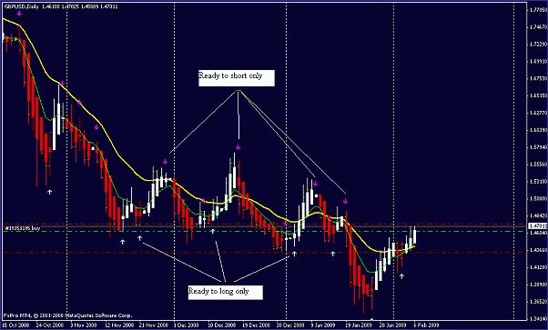

For all of you,
just wanna show you a very good advice from seniors i have read from this forum, I guess you have to read it, specially for newbie.
http://www.forexfactory.com/showthread.php?t=27286
http://www.forexfactory.com/showpost...1&postcount=75
KEEP REMEMBER THAT 95% TRADER FAIL, EMOTION PLAYS CRUSCIAL PART,EVEN THE BEST TRADING SYSTEM IN THE UNIVERSE WILL FAIL IF YOU CANT MANAGE EMOTION, PICK THE SIMPLEST TRADING SYSTEM FITS YOUR RYTHM AND MANAGE YOUR EMOTION THEN SUCCES IS IN YOU HAND.
DETTACH YOUR EMOTION, THINK IT AS A NUMBER NOT MONEY
"EA IS TO MAKE YOUR TRADE EASIER NOT MAKE YOUR LIFE EASIER" so dont put your whole life in it, I call it driven EA and it still needs our brain to make it succes, it is a semiautomatic EA not fully automatic, only part of trading is handled by this EA.

- Technical question

How do I put the EA, Indicator and the template?

Put the EA to following folder:
C:\Program Files\MetaTrader\experts

Put the Indicator to following folder:
C:\Program Files\MetaTrader\experts\indicators

Put the template to following folder:
C:\Program Files\MetaTrader\templates

Restart your Meta trader software

How to drive the EA?

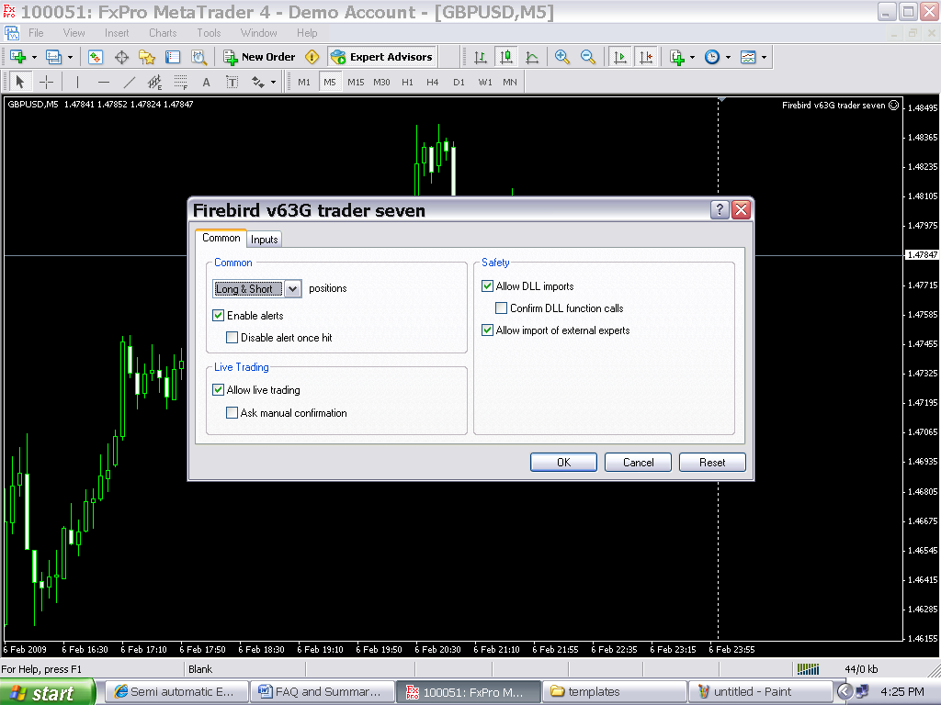

- Put the EA on 5 min chart: click the “navigator” toolbar button, find the EA on the expert folder and then drag it to the chart.
- Click the “Expert Advisors” toolbar, make sure it turns to green.
- Activate the EA so that it can go live: Press F7 to show the EA properties, on “common’ tab make sure u check the “Allow live trading” checkbox, if u see the smile icon the right top of the chart, it means the EA is ready to go.
- How to drive the EA: above the “Allow live trading” checkbox u can find the optional box where u can choose to go “Long only”, “Short only”, or “Long & Short”

How do I adjust the EA for 4 digit or 5 digit broker platform?
Try this setting:
5 digit broker platform
SL : 3000 (means 300 pips)
TP : 500 (means 50 pips)
Pipstep : 400 (means 40 pips)
4 digit broker platform
SL : 300 (means 300 pips)
TP : 50 (means 50 pips)
Pipstep : 40 (means 40 pips)
=================================== =================================== ======
Why does the EA open many position?
pipstep setting
usually 20 open position at the same time is not normal, maybe u should check the setting for the pipstep.
lets me show u this,the default setting for pipstep is 40 pips, then when u open buy position and then the market goes against u for -40pips, then the ea will open another buy position, it will do the same thing when it touch -80pips and so on. so check your pipstep and adjust it to your broker platform, the default is for 5 digit broker platform.
so according to SL for 300 and pipstep is 40 then maximum open position at a time is 300 devide by 40 is 7 maximum open position at a time.
=================================== =================================== ======
Why does my EA is not working?
Perform this check
1. Have u set the EA to "Allow live trading"?
2. Activate the button "Expert Advisor" on the toolbar
3. Make sure there is a "smile icon" next to your EA on the right top of the chart
4. Adjust the setting according to your broker platform
5. Check the internet connection, since this EA needs a very good up time internet connection.
=================================== =================================== ======
Can I change the setting for SL, TP and Pipstep? SL is too big for me
Of course yes, as u feel comfort, the point is that I informed u about the major idea of "driving the EA". Just try your optimum setting fits your strategy.
=================================== =================================== ======
How do I backtesting this EA?
U have to drive the EA according to the major trend even its on backtest, just exactly when U foward test it. drive the EA each time u find a trend reversal in a spesific day.
Like I mention before, try to backtest it for 1 month on Aug 2008, becouse that month the market shows down move from start to end, drive the EA short only and u will see that.
################################### #################################
Non Technical question
What did U do when the major trend reverse?
It depends to the market,I usually look for the daily candle pattern as my other indicator, but when the market is about to change I close all the opening position of course. This is what I do when I noticed and assumed that the market is about to change:
1. Safe way, not trade when the market is in the midle of changing direction, and continue to ride the market when the trend is clear, this avoiding drawdown, just take 7 days trading in a month and you probably got 1000pips. Strongly recomended to use this way.
2. Unload the EA and put SL and TP lower (20 - 40 pips) on the opening position, or close all of the opening position even if its negative, and start to load the EA again according to the major trend when I see the major trend is clear.
3.Still trading when the market is about to change, I use this just to confirm when the market is about to changing, when I see the frofit for the day less than 100 pips or even negative (but often still profit but minimum) that means I have to Drive the EA accordingly. But I dont recomend this, I only use this way on the demo.
=================================== =================================== ======
How do u recognize a clear major trend?
Clear down trend
when the chart turns red and the arrow pointing down and the candle pattern confirm it ( I suggest U to learn candle pattern, I got this suggestion from Phillip Nell with his great 4H MACD strategy), thats where the high probability of the next daily candle move down. if one of this indis is not in the line it means that u have to becareful, or much better not to trade, trade 7 days a month is enough to have "maybe" arround 1000pips.
U can use your own indis as u feel comfort.
Clear up trend
vice versa
=================================== =================================== ======
Why do you use 300pips for the stoploss?
300 pips is to give space for the market retracment.
from what I know that it is still save as long as u still follow the daily trend, when it's negative dont worry becouse the market will recover it (as long as u follow the daily trend), its normal to have negative open position becouse this EA will open the position on retracment. Let me show u
Lets say the daily trend pointing to move down , but the price dont moves smoothly down right"?,it retrace (against the daily trend for temporary), when it retrace the EA will open position, it means that it will be negative for a while but soon the market will recover your position to positive becouse you follow the major trend.
So make sure that u follow a clear trend.
=================================== ======================
If you see the trend is clear so why you have to use this EA?
My experience is that this EA can catch pips more than the market pip range , for example from January 1st Jan to January 7th the price move down for 500 pips, then this EA can catch more than 500 pips from the price retracement, just try this EA on back test for 1 month on Aug 2008 you will see that.
=================================== ======================
What pair do you trade?
I used GBPUSD and EURUSD or you can try another pair, just look for the pair that shows a clear trend in daily chart.
=================================== ======================
Regards,
Samurai Power

